RFID Mobile Blue tooth Reader Manual
Introduction
Appling Mobile Blue tooth 4.0 into RFID access area is a total new technology. Just install ‘App’, shake mobile near reader or click ‘one click to open’, then finish Identification, and realize opening door via Mobile in true meaning.
Specification
1.Working voltage：9～12VDC。
- Current: average 50mA, peak 100mA
- Frequency: 125 KHz or 13.56 MHz; Mobile Blue tooth 4.0
- Communication interface: Wiegand26, Wiegand34
- Environment: temperature -20℃～65℃, humidity 0 ~ 95%
- Reading distance: RFID Card: 1～5cm;bluetooth：0-5M 7. Connection cable: 8pin shielded twisted pair, max 100 m.
8.Size：86*86*18mm。
- Housing material: ABS
- Supported technology: Bluetooth 4.0 on Android 4.4+ or ios 7.0+
App Install
- Scan QR Code by browser on mobile phone and install APP
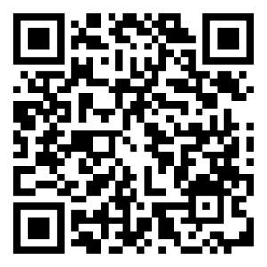
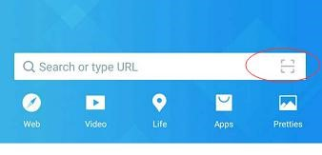
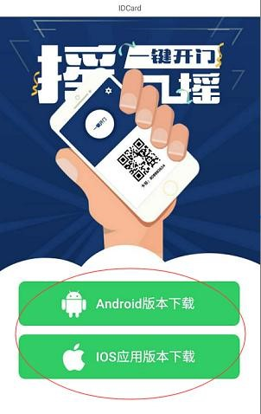
- Register as users:
Open app-, click “register now”；
Set the Mob.No. as account ； Enter User Name and PIN ； registration can be completed.

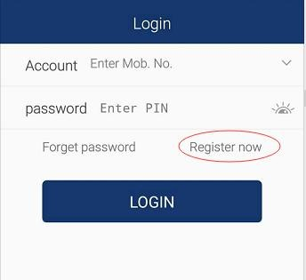
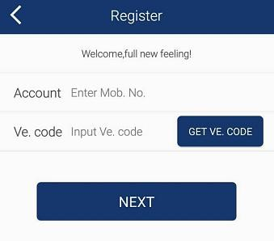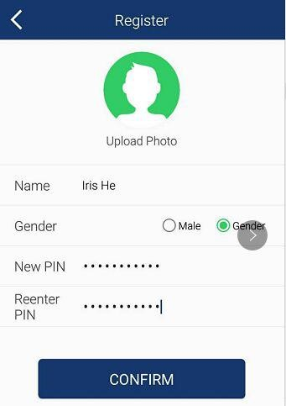

3.After registration, login with user name and password, open Mobile Bluetooth function menu, shaking mobile during 1 -5M reading range or click “one click to open’, the door will be opened.
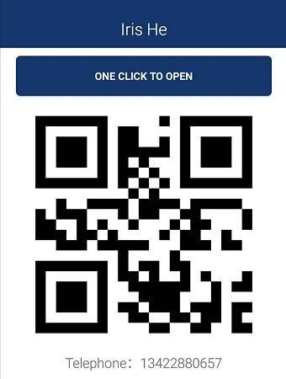
Notice:
- If several RFID readers are existed, App software will search them all, select the needed reader.
- The reading distance is based on Android Mobile Blue tooth transmission. Please try to keep near distance with reader.

