PB-205Rwireless convertor

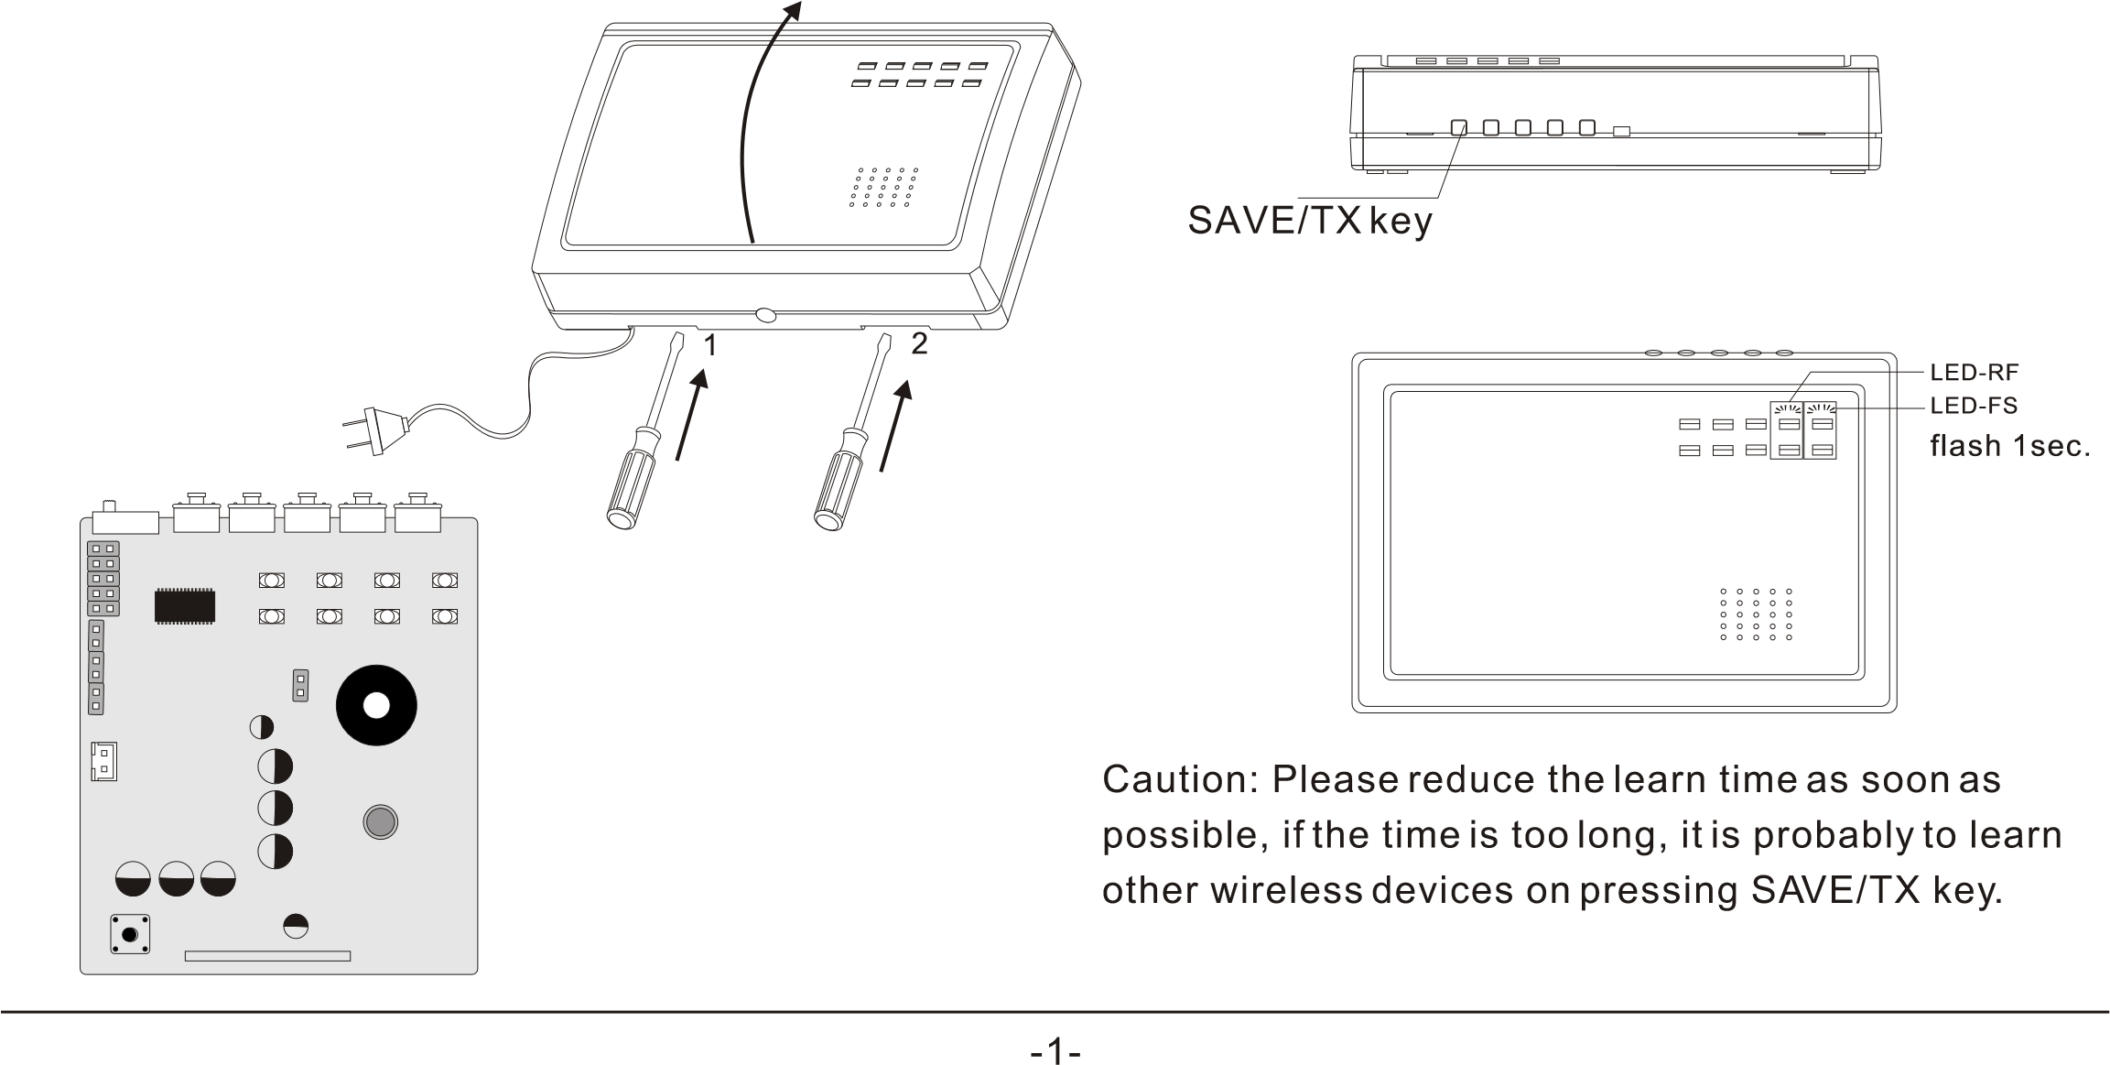PB-205R wireless convertor adopts MCU. The product which is adopted in the long distance transmit and in the environment of strong obstacle can amplify the signal to panel. It can convert up to 60 detectors. For voiding interference, it is combined with detectors one by one through learn enrollment mode. It is only convert its attached detectors. It can convert wireless signal up to 10 kil distance through max 15 convertors. Ex. On requiring muti- level transmit, this convertor which adopts database exchange model between the levels transmits the signal including itself address code and detector message to the next convertor till the final. The others

Input voltage. 180V~240V AC

are not necessary to learn the detectors except the first

convertor. Self-taking anti-tamper switch.

.Characteristic

2

.Installation and draw wire

3

A. Refer to below

First, remove fastener 1 and 2 via

screwdriver according to arrowhead; Then open the

cover, you will see the inside structure.

4

. Enrollment(learn mode

)

Refer to below Fig, first press SAVE/TX key then

trigger the wireless detector; After LED-RF and

25

mA

Work current

mA

130

Wireless receive distance

m

120

Wireless transmit distance

m

1000

no barries

Dimension

167\*112\*40

mm

Static current

LED-FS light synchronously 1 second ,undo the B. Refer to follow FigDraw the battery wire to the battery SAVE/TX key. The enrollment is finished. Other terminal. There is a switch for Open/close battery power. detectors repeat above.

