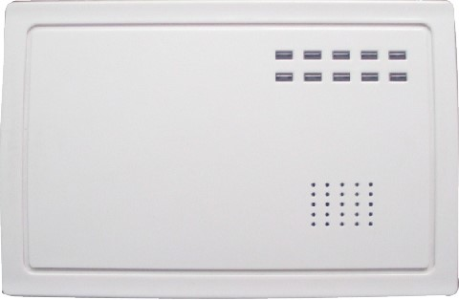
FC-008R WIRELESS TO WIRED REPEATER
FC-008R repeater convert wireless signal to wired signal
and It can convert signal for max 8 wireless device. Please
code the wireless device to the repeater before using.
1
Introduct
Appearance
2
Specification
2.1
can code max 8 wireless device.
2.2
wireless signal frequence
433
MHz
2.3 work voltage
11.5-15.5
V
2.4
work current
33-39
mA
3

Installation
Buckle to 3.1 Open the coverScrew hole install PCB Screw hole
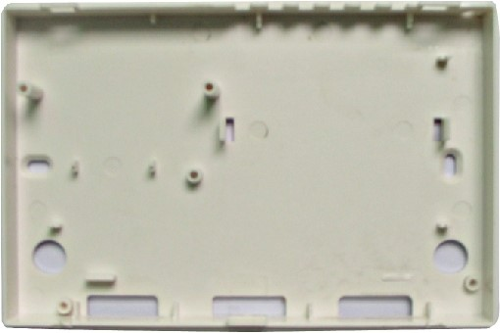
3.2 Remove the PCB.
3.3 Put the base cover on the wall and point out where to drill hole for screw.
3.4 remove the base cover and drill hole on the wall.
3.5 Put the base cover to the wall, let the wire of the device which will connect to the repeater through the wire outlet hole and connect it to the repeater.
3.6 Fix the base cover on the wall by screw in screws. Wire let-in hole
3.7 Install the PCB back.
3.8 Cover the face case.

Coding and delete coding
4
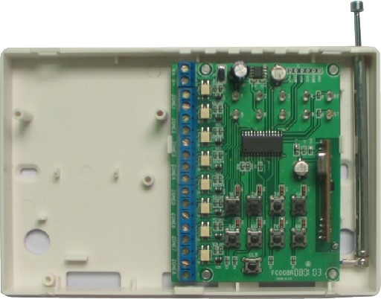
4.1 Coding wireless deviceconnect the power press the switch of each zone, then trigger the wireless device, the LED according to the zone will light-off for 5 seconds. Then coding successfully.
NO.1 switch
NO.1LED
+

-
Power
Eg, coding the wireless device to the NO.1 zone, press the NO 1 switch, then trigger the wireless device, the red No.1 LED will be off for 5seconds, then coding successfully.
4.2 Delete codingIf need to recoding another wireless device to a zone which had coded with a wireless device already.
You need to delete the coding first. Operate as below: press and hold the switch of the zone which you wan to delete coding and then press [CLR] switch the yellow LED will normally on, then delete successfully.
5
Transmiting wireless signal

Trigger the wireless device which had coded to the repeater, the LED of the zone will l light-off for 5 seconds, and the relay output terminal of the zone will open for 5 seconds. Eg. a wireless detector has coded to NO 3 zone, when trigger the detector, NO.3 LED will turn off for 5 seconds, the wired output terminal will open for 5 seconds.

