RView
Mobile client User Manual
V1. 0. 1
table of Contents
1. Product Introduction 2
1.1 Product Overview 2
1.2 Main features 2
2. Software Installation 3
2.1 operating environment requirements 3
2.2 acquisition software 4
3. Software Operating Instructions 4
3.1 Introduction to login screen 4
3.2 Live Preview 6
3.3 Remote playback 7
3.4 Equipment management 8
3.5 Message Center 10
3.6 Image Browser 11
3.7 Alarm Notification 13
3.8 About help 13
3.9 logout 14
3.10 Account Management 14
3.11 Language switching 14

Product Introduction

Product Overview
RView is a professional mobile video surveillance software, with the specified DVR, network camera.

Main features
The main function:
- Sign up, change password, forget password
- Real-time preview (intercom, monitor, PTZ control)
- Device management (add, delete, modify settings)
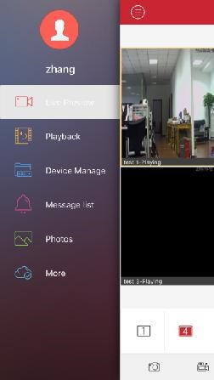
- Remote playback
- Arming the alarm
- Image browsing
- About help
- Account Management
- Digital password lock
- logout
Figure 1.1a

Software Installation

operating environment requirements

Apple's mobile client requirements ios6.0 above system; Andrews mobile client requires android 2.2 and above system

acquisition software
Apple mobile phone users: Search LView installed in the Apple App Market (appstore) on.
Android mobile phone users: Google Market
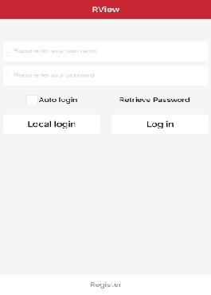
(google play), search for treasure RView installed application, Android Market and other major applications.

Software Operating Instructions

Introduction to login screen
After successful installation, click on the phone Software icon, the software can run. Start the program to enter the login interface, as shown below
Functions | Introduction
Login | Account login, device information can store in the cloud storage
Remember me | After the check, remember the current user password
automatic logon | Check after the start of the software automatically login account
Local login | Without account directly into the device saved in the phone
- User registration
Register an account, the account for cloud storage of our user information and related equipment list, in the login menu, click the "user registration" button, jump to the registration interface:
Functions Introduction  Username user login (only letters and numbers, "-", "_", "@" character)  Password login password (6 digits or more)  Confirm password enter the password again  Email email security, please fill in the correct, to forget the password you can reset the password  Cell phone number optional | 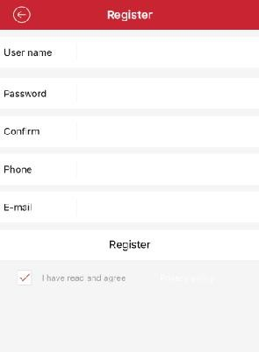
Figure 3.1b
- Find the password
In the login interface, click the "retrieve password" button, jump to "retrieve password" interface:
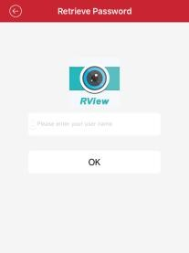
1.Enter the user name to retrieve the password
2.Click "retrieve password", the system will send a reset password link to our registration set when the mailbox, enter the mailbox according to the prompt set password
Figure 3.1c

Live Preview
Click the device icon in the device list to enter the playback interface, as shown below:
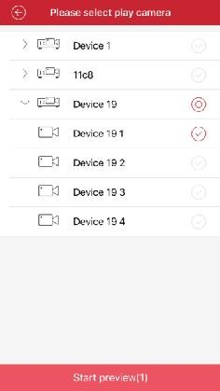
Figure 3.2a Figure 3.2b
Double-click the window to enlarge the screen when playing, horizontal screen can be full-screen playback.
Video monitoring interface buttons function description, as shown in the following table:
Button icon | Function introduction | Button icon | Function introduction
 | View main menu |  | Capture
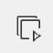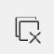 | Play / stop |  | Local video
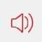 | Open / close monitor | 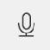 | Start the intercom
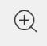 | Playback channel amplifier | 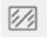 | Bit Stream Switching
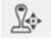 | PTZ camera control | 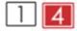 | Multi picture switching

Remote playback
The mobile client can access the remote device, retrieve the video data stored on the hardware, and need to have the storage device in order to realize the remote playback function.
In real-time preview interface selected to be played back window, click on the remote playback menu to enter playback interface, default video player that day.
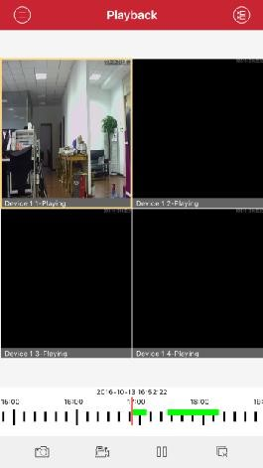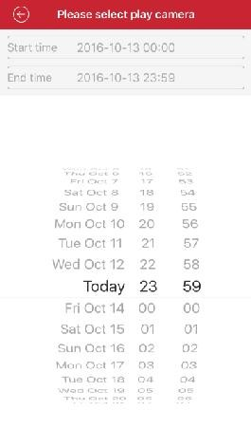
Figure 3.3a Figure 3.3b
1, click on the channel can choose otherdates, select the date you want to play can be.
2, below the green area for a video time, can be dragged to the progress bar to play the time to play

Equipment management
After entering the main menu interface, select "Device Management" to enter the management interface
Icon | function declaration
 | Return to the main menu list
 | Add equipment
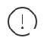 | Click to modify connection parameters
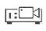 | Device, click to play all channels
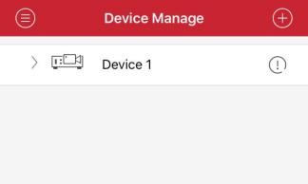
Figure 3.4a
 Add a device
Click the top right corner Add button to enter the device to add the interface, enter the device can be manually added to the connection parameters, you can click the search button in the LAN search device to add.
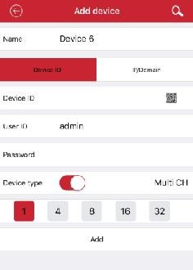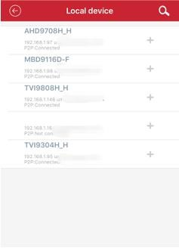
Figure 3.4b Figure 3.4c
- Connection mode: serial number and IP / domain direct connection of two ways. Cloud way is to use the device serial number to connect; ip way is to use the traditional ip address or dynamic domain name and port to connect the device. By default add the serial number, the point above IP / domain switch to ip mode.
- Name: is the name of the monitoring device, it can help you identify the location of the device, we recommend that you place the device by which a name, the name will be displayed under the device icon will appear on the title while playing
- Serial number: Cloud Connector unique serial number, the device can be carried in the label or Intranet search, you can click the input box to the right of the two-dimensional code input
button Dimensional code scanning input
- Username: front-end equipment the user name, the default is admin;
- Password: password Username front-end equipment, and front-end equipment to match, default is empty After filling out the settings, click OK, point after the pre-connection check device will automatically fill in information is properly and correctly will automatically return to "Device List" screen, click
on the device, you can view the video; not correct, click device, Tip: Equipment offline.
   Modify, delete the device
- Connection parameters: You can change the name, serial number to connect to the user name, password, connection parameters.
- Delete Device: Click Edit, you can see a "delete
this device", click "remove this device" button and click "OK" to delete.

Message Center
When the device generates an alarm, the device sends an alarm message to the server. The message is then sent to the mobile client through the server. The mobile terminal displays the notification in the message center.
Click the top right corner Delete button, you can delete all alarm records.
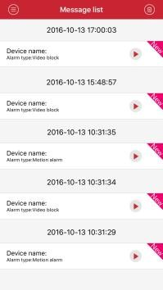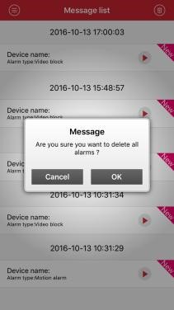
Figure 3.5a Figure 3.5b

Image Browser
Live preview when clicked After that, the generated image is stored directly in the phone, from the menu into the local video or local album can view
or
   Playback images:
  ➢ Click on the video compression column chart, you can select the player to play.
  ➢ Click on the captured image to open it.
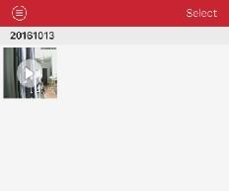
Figure 3.6a
 edit delete:
   ➢ Top right, click "Select" button, select the edit list into a state, select the files you want to delete click the bottom right corner Button can be.
   ➢ Top right, click "Select" button, select the edit list into a state, select the phone needs to be saved to a local file clicking on the left Button can be.
Figure 3.6b

Alarm Notification
Turn alarm: device management interface to select the channel point alarm modification Enter the setting interface, turn on the channel name confirmed alarm, alarm notification and arming switch open, save, indicating success can be.
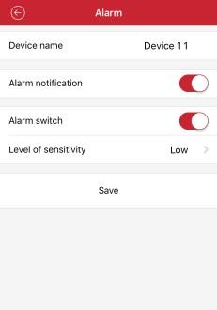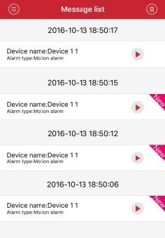
Figure 3.7a Figure 3.7b
 Push notifications: the success of the arm and turn the lens notified when the device generates an alarm, the device sends an alarm message to the server, and then send the message to the mobile client through the server, mobile terminal to notify the prompt. As shown in Figure 3.7b

About help
You can query the software version information

logout
Click "Logout" to exit the current account login, and return to the login screen.

Account Management
Click the user picture, you can choose to automatically login, modify the password function

Language switching
When the phone operating system to change the language, the language of the software with the replacement. For example: mobile phone operating system language is replaced with English, then the phone software language will be replaced with the English.

