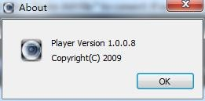
RecordPlayer Tool Manual
- Open folder RecordPlayer
- Double-click to open the operation interface as below.
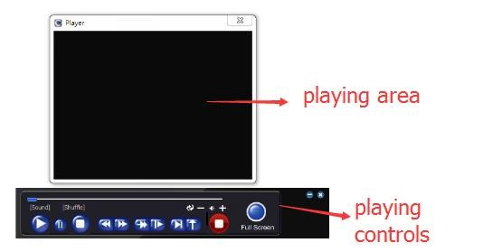
- Drag the Record file into the record playing area to play.
- Play controls description
button | function | button | function
 | Play |  | Pause
 | Stop |  | Fast Forward
 | Fastback |  | Twice fast play
 | Slow play |  | Frame forward
 | Snapshot |  | Loop
 | Audio |  | Full screen
/ | Decrease volume/Increase volume |  | Start Record
/ | Minimize/Close
- Shortcut menu
Right click in the playing area to enter shortcut menu .
  - Convert to AVI
Function: Convert h264 format file to AVI format file.
Step 1: Click “Convert to AVI” , it will pop up the dialog box as below.
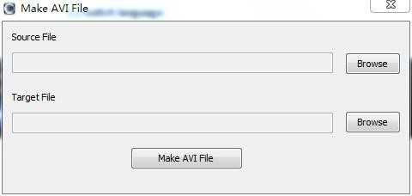
Step 2: Click “Browse” to find the file you want to convert.
Step 3: Click “Make AVI File” to convert. If success ,it will pop up “ok” prompt box.
  - Switch language
Click “language” to choose the display language. It support Chinese and English.
  - Check system version
Click “About” to check the system version as below.

