LView
Mobile client User Manual
V1.0.0
contents
1. Product Introduction 1
1.1 Product overview 1
1.2 Product main functions 1
2. Software Installation 3
2.1 Operating environment requirements 3
2.2 Get software 3
3. Software operating instruction 3
3.1 Login interface introduction 3
3.2 Device management 5
3.3 LIVE view 7
3.4 Remote playback 9
3.5 Alert notification 10
3.6 Image browsing 11
3.7 About 12
3.8 Logout 12
3.9 Language switch 12

Product Introduction

Product overview
Lview is a professional mobile-phone video monitoring software, matching with specified hard disk video recorder, network camera.

Product main functions
Main functions:
- Register, login, retrieve password, modify password
- LIVE view (Bidirectional talk, monitoring, PTZ control)
- Device management (Add, delete, modify, setup)
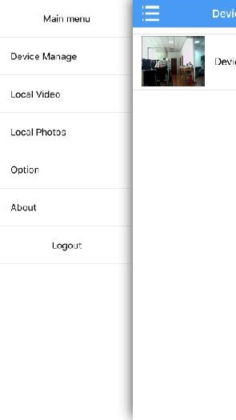
- Remote playback
- Alert notification
- Image browsing
- About
- Logout
- Language switch

Software Installation

Operating environment requirements
iPhone client requests ios6.0 above system, while Android client requests Android 2.2 or above system.

Get software
iPhone users: Can search and install Lview in the appstore
Android users: Can search and install Lview in the google play, Myapp, Android Market, etc.

Software operating instruction

Login interface introduction
After install successfully,click software icon on the mobilephone, then the software will be running and start procedure to enter into login interface, as shown in the below figure:
 Create
account
Create an
Functions | Introduction
Login | Account login, device information canstore in the cloud storage
Remember me | Click to remember the current account password
Auto login | Click to realize auto login accountwhen start the software
Local access | Candirectlylogin without account, device store in the phone
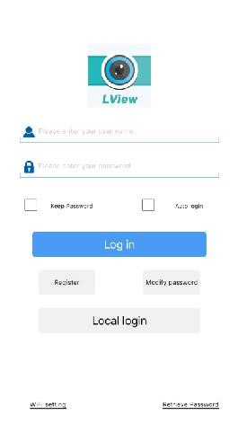
account to be stored our users information
and relevant device list in the cloud storage. In the login menu, click Create account button, it will link to registration preview:
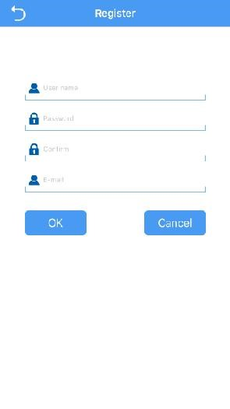
1.User Name: To login (Allow only letters and numbers, "-", "_", "@"character)
Figure 3.1b
2.Password: Loginpassword (More
than 6 digits）
3.Confirm Password: Inputpassword again
4Email: Please fill inencrypted password

 Retrieve password
Click Retrieve Password button in the login interface, then it will link to Retrieve Password interface:
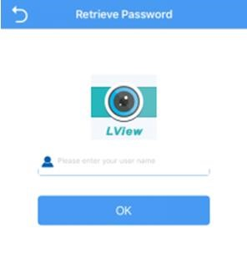
1.Input user name
2.Click Retrieve Password, the system will send a URL to the Specified mailbox to reset password, then reset password according to prompt
Figure 3.1c

Device management
After enter into main menu interface, click Device management to enter into management interface.
Icon | Function Instruction
 | Return to main menu list
 | Add devices
 | Click to modify the connection parameters
 | Device, click to can be played all channels
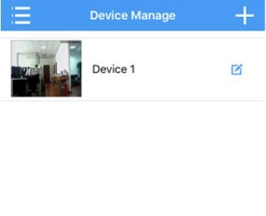
Figure 3.2a

 Add device
Click Add iconin the upper right corner to enter into Add Device interface, it can be manually added connection parameters of device or click Search button to Search and add devices in the LAN
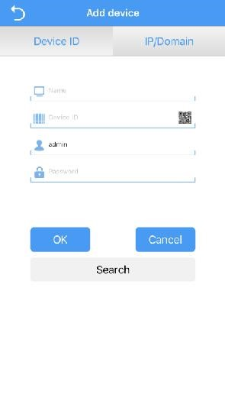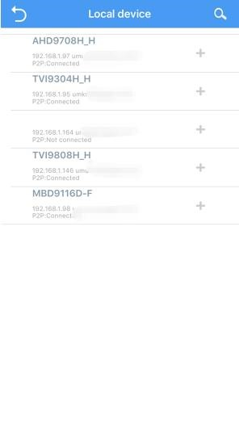
Figure 3.2b
Figure 3.2c
- Connection mode：There are serial number and IP direct connection two methods. The cloud method is to connect device via serial number, IP method is to connect device via traditional IP address,dynamic domain name or port. Adopt serial number to add device for default, click upper IP to switch IP method
- Name: That is monitoring device name, it can help user identify device location, suggest user give a name for the device according tothe place name, then the name will be displayed under the deviceicon and shown on the title during playback the video
- Serial number: Device cloud connects the only serial number,which can be obtained via the device label attached or LAN searching, click the QR code iconon the right side to scan input
- User name: That is user name of front-end device, default is admin
- Password: That is password of front-end, matching with the user name of front-end, default is null
After complete settings, click OK,then it will be automatically pre-connected to check device information whether be correct or not. If it is correct, it will return to the Device list automatically, If not correct, click on the device, prompt: the device is offline.

 Modify and delete device
- Connection parameter: Can be modified the name and connection parameters, such as serial number, user name, password, etc.
- Delete device: Click Modify, you can see the "delete this device",Click "delete this device" button, click "OK" to delete.

LIVE view
Click device icon in the device list to enter into LIVE View interface, as shown in the below figure:
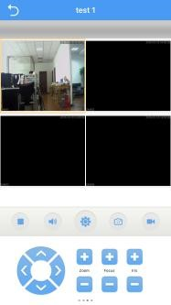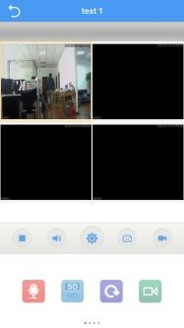
Figure 3.3a | Figure 3.3a
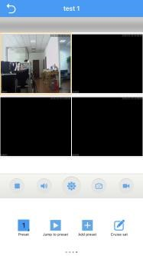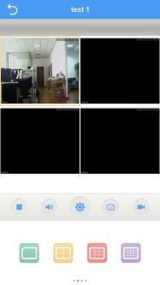
Figure 3.3a Figure 3.3a
Double-click to zoom the screen, can be full-screen playback via landscape, and slide through the screen to switch channel group and function menu, as shown in the above figure 3.3 b.
Function introduction of video monitoring interface button keys, as shown in the below figure:
Button keys icon | Function introduction | Button keys icon | Function introduction
 | Return to device  list |  | Enable  bidirectional talk
 | Play/Stop |  | Stream switch
 | Enable/disable monitoring |  | Playback
 | Alert settings |  | Remote playback
 | Snapshot |  | PTZ lens control
 | Local record |  | Multi-screen switch
 |  | 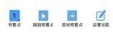 | Cruise set

Remote playback
The App can access device remotely, call the record files stored in the hardware. The device with storage function can realize remote playback.
Select the playback window in the LIVE View interface, click the playback icon to enter into playback interface, the current record for default.
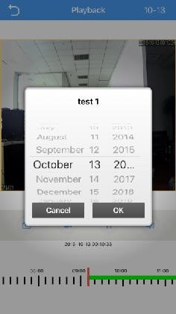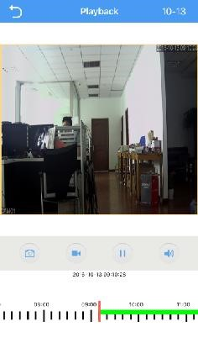
Figure 3.4a Figure 3.4b
- Click the upper right corner to select date optional
- The below green zone for video timing, can drag the
progress bar to play video in specified time

Alert notification
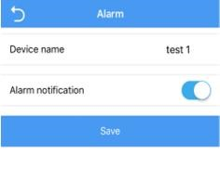
- Enable alarm: Click configuration icon to enter into Alert Setting interface in the LIVE View interface. Select to enable alarm channel in thealarm configuration, click Alert notification, then click Save, when prompted device modified successfully, the configuration will take effect 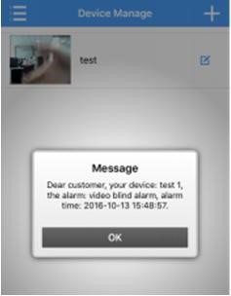
Figure 3.5a Figure 3.5b
- Alert notification: Set up defense and enable alert notification, when the device give a alarm, it will send alarm information to server, then the alarm information will send to phone client via server, and the client will prompt via alert notification, as shown in the above figure 3.5 b

Image browsing
Click iconin the LIVE View interface, the generated images will directly store in the mobilephone, can be viewed from the menu to enter into local video or local albums.
or
- Playback images:Click shrinkage column figure, select player to play images
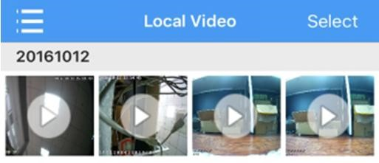
Figure 3.6a
- Edit and Delete:Click the Edit iconin the upper right corner, then the listcan be edited and selected, select and click the files need to be deleted
Figure 3.6b

About
Can query software version information.

Logout
Click logout to exit from the current account to login, and return to login interface.

Language switch
The language of phone software is in accord with the language of phone operation system, When the phone operation system change the language, software will also change its language. For example,when the language of phone operation system is changed into English, then the language of software will also be changed into English.

