DVR Quick Operation Manual
Version 1.0

Statement
This manual only introduces the basic operation. For the specific ones, please refer to the electronic manual in CD.
In order to adapt to different types, this manual won’t list for eachspecificoperation. Our company reserves the right of final interpretation of it.

IMPORTANT NOTICE
The following is about the usage of our product, danger prevention and how to prevent the loss of property, etc. Be sure to follow the rules when using it.
- Do not place containers filled with liquid on DVR
- DVR should be placed in a ventilated location
- DVR should work in the allowable temperature and humidity range
- Dust on the PCB board of DVR will cause short circuit after damped, so please clean on the circuit board, connectors, chassis and chassis fan with a soft brush regularly

Product features summarized
- Real-time monitoring
With composite interface of video signal, itsupports VGA and HDMI output simultaneously.
- Compression processing function
It adopts H.264videocompression standard and G.711 audio compression standard.
- Recording feature
It supportsseveralrecording modes, such as timing, alarm linkage, dynamic detection, etc. It supports the S.MA.R.TR technologyfor the SATA hard disk and the local hard disk, andprovidesboth USB and network interface for backup of the recording files.
- Video playback function
It realizes local and remote playbackby retrieving videos according to different conditions,and supports fast forward, slow forward, rewind and frame-by-frame modes while multi-channel videos playbacksimultaneously; It can show the exact time of the incident during the playback of video.
- Camera control and alarm
It supports for remote camera control. With multi-channel alarm input interfaces, it can be connected to various types of alarm equipment. It supports the video alarm function for dynamic detection, video loss and video occlusion, etc. With multiple alarm outputs, alarm linkage and lighting control can be realized.
- Communication interface
With USB2.0 high speed interface or the SATA interface, it can be connected to many external backup devices.With standard Ethernet interfaces, it realizes Plug-and-play under various network conditions.
- Network functions
It supports a wealth of network protocols, such as TCP/IP, UDP, RTP/RTSP, DHCP, DDNS and NTP, etc. It also supports real-time monitoring via network, video playback, controland management functions.With a built-in WEB Server, it can be accessedby browsers directly.

Part 1 Basic operations

1. Basic installation

1.1 Installation for the hard disk
For the first use, please install the hard disk firstly. The number of hard disk installed depends on the actual needs and product specifications.
NOTE: If the hard disk is not installed, the device can work normally for monitoring, but can not record or playback.

1.2 Mouse operation
Both the front and rear panel has a USB port; The two ports can be connected to mouse, U disk or WIFI module. For different products, it depends on the product specifications to connect the mouse.

2. Boot
Connect the power, turn on the power switch on the rear panel, the power indicator will be lit, and the DVR boots. A "beep" sound from the buzzer will be heard after the device started, and the default video output is multi-screen mode.
NOTE: When the power is turned on after abnormal outage, the device will automatically recover to the previous status.

3. Shutdown
To turn off the device, you may choose soft switching or hard switching. For soft switching, enter [Main menu]> [Logout], and select [Shutdown]; For hard switching, press the power switch on the rear panel directly (Hard switching may result in data loss, so please use with caution).

4. Login
After the device boots up, the user must login and the system provides the corresponding functions according to the permissions of the logged in user.
When the device is delivered, there are two preset users: admin and guest, no password by default. The factory preset user of admin is with superuser privileges; the factory preset user of guest is with permissions for preview and video playback. For both users admin and guest, password can be modified, but permissions can not be changed.
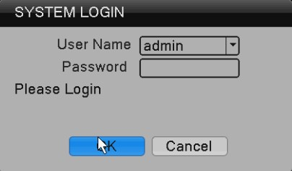
Password Protection: If the password is entered wrong for 7 times consecutively, there will be alarm to lock the account(after the system reboot or half an hour, the locked account will be unlocked automatically). For security reasons, please change the user name and password in the “User Management” in time. 5. Preview
After the device log in, it enters the multi-screen preview mode.
In the channel of preview, it displays the date, time and channel name; and each screen can display video and alarm status for the monitoring channel. The normal interface is available with the following icons: channel name, recording flag, and audio flag. When an alarm is triggered, it appears alarm and other status flags, such as video detection, video occlusion and video loss.

6. Encoding settings
By setting the encoding parameters, it achievesthe high-quality playback and remote monitoring capabilities. By the following means, you can find the interface of the feature settings: [Main menu]> [System]> [Encoding]; the interface is as follows.
NOTE: For different model, the option of encoding resolution is different.

7. Recording settings
Recording settings mainly include settings of the length of the video, pre-recorded time and period of time. By the following means, you can find the interface of the feature settings: [Main menu] → [Recording] → [Recording]. The interface is as follows. The displayed settings of this interface is the default settings of the system.
Note: For normal recording of the device, at least one of the installed hard disks is set as read-write.
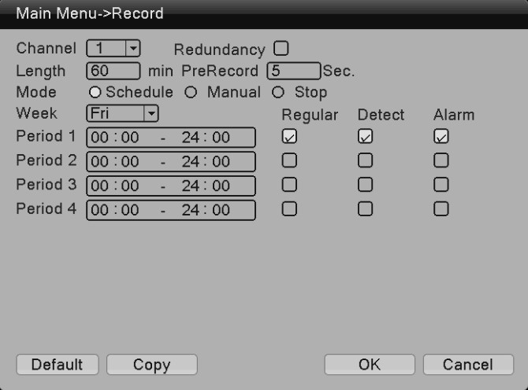

When selecting the video format, you can set for each channel according to your own needs; it is recommended to use the default (the default is a period of 24 consecutive hours with configuration, regular, detection and alarm selected simultaneously).

8. Video playback
Video playback includes video query, playback and other operations. Ways to open the video playback are as follows. The first way is: Right-click in the preview screen, pop-up a menu, and select [Video playback] in the menu; The second way is: [Main menu] → [Recording] → [playback]. The interface of playback is as follows:

8.1 Video query
Select the time period, and click the inquiry key on the lower right corner. After the query completed, click to jump to the query interface, as shown below:
In this interface, user can select to query again.
[Time query ]
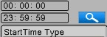
[Video mode query]
After selecting the query criteria, click [OK].If there is the corresponding record for the entered query condition, the video file of query will be displayed in the list on the right in the playback interface; the list can hold up to 128 files.
8.2 Video play
You can double click on the file to play, or you can click the button of Play.

9. Network settings
By [Main menu]> [System]> [Network], you can make the native network settings.
[IP address]: factory default 192.168.1.18; [Subnet mask]: factory default 255.255.255.0; [Gateway]: factory default 192.168.1.1.
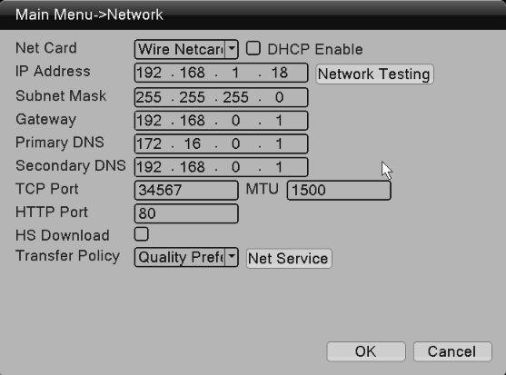
IP address of the device should be set in the same network segment with the router; For example, if the IP address of the router is 192.168.1.1 and the subnet mask is 255.255.255.0, the default settings are OK. Usually the default gateway is the router's IP address. Input the IP of the device (192.168.1.18) in IE can achieve the device access in LAN. If you need to access the device via public network remotely for video surveillance, you can refer to the "Network Setup Guide" for the specific settings.

10. Motion detection settings
Motion detection is mainly divided into two parts:
Alarm function settings of motion detection (enable switch, sensitivity, detection area, the time period of arm and disarm and the time interval), that is, how to set to make an alarm.
Linkage settings of motion detection (screen prompts, beep, alarm output and round tour) and others that need to be combined with other function settings (such as linkage recording and sending Email), that is, how to dispose after the alarm.
You can find the interface of function settings by the following means: [Main Menu] → [Alarm Set] → [Motion Detection]; the interface is as follows:
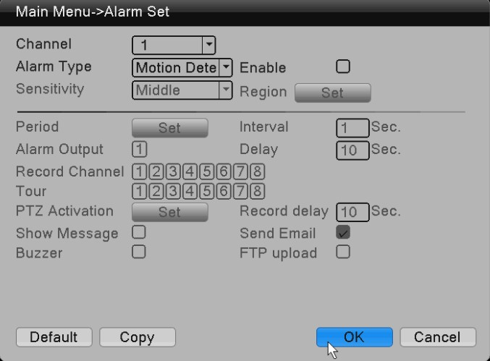

Part 2 Remote control
Enter the IP address of device in the browser for remote access.Due to the influence of the network, you need to download and install the controlsfirstly for network remote monitoring; individual product may needto use CD or install the plugin manually. Otherwise you can not access the deviceremotely.

1.Web remote access

1.1 Web login
After the network connected, usea browser the PC comes with, and log in the
DVR for remote monitoring. For details, please refer to the “WEB client instructions”.
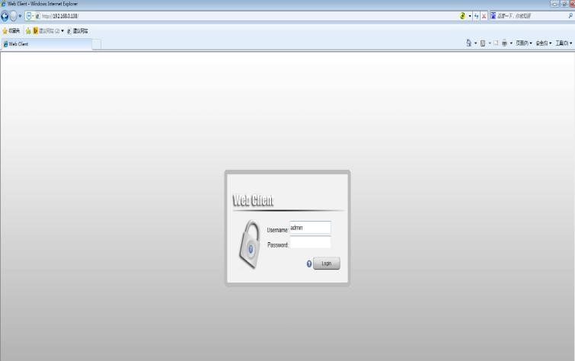
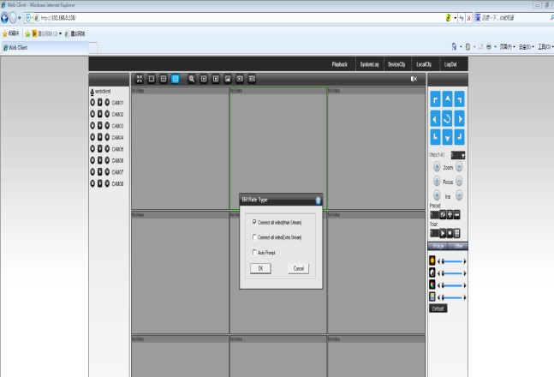

2. CMS3.0 remote access
CMS is a professional software for remote monitoring of multi-devices, with advantages of safety, convenience, stability and unified management of multiple devices, etc. It’s easy to install anddo not need to downloadplug-ins. we recommend that customers use it. For details, please refer to the manual of CMS3.0.
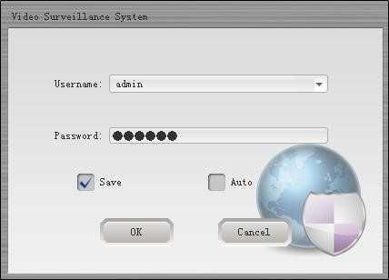
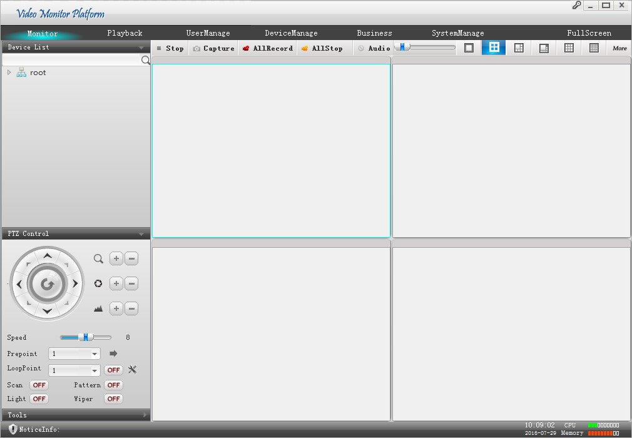

3. Mobile phone monitoring
The function of mobile phone monitoring is enabled by default;
Software for mobile phone monitoring: RView or LView
Port for mobile monitoring: 34567
Go to System settings -> Network services ->Cloud services, and it can be viewed.

Thank you for reading; if any doubt, please contact with us.

