CMS Video Monitor Platform User Manual
声明
非常感谢您购买我公司的产品
，
如果您有什么疑问或需要请随时联系我们
。
C
MS3.0 U
se
r
M
anual
This user manual will be updated when the product’s function enhanced, and will regularly improved and updated the product’s description or the process. The updated details will be added into the new version. Forgive us to not notice you in other ways.

CONTENT
- Installation&working Environment ..................................................................... - 5 -
  - Summary ................................................................................................. - 5 -
  - CMS Working Environment.................................................................... - 6 -
  - CMS Installation ..................................................................................... - 6 -
  - CMS Uninstall......................................................................................... - 6 -
- The Operation of CMS......................................................................................... - 7 -
  - Login CMS.............................................................................................. - 7 -
  - Log Out ................................................................................................... - 9 -
- The Features of CMS........................................................................................... - 9 -
  - Real time Monitoring .............................................................................. - 9 -
    - Split Screen................................................................................. - 9 -
    - Device List.................................................................................. - 9 -
    - Video Monitoring ..................................................................... - 10 -
    - PTZ Control.............................................................................. - 10 -
    - PTZ Setting............................................................................... - 11 -
    - Tools ......................................................................................... - 13 -
    - Notice Information ................................................................... - 15 -
  - Device Management.............................................................................. - 15 -
    - Device Group................................................................................. - 15 -
    - Network Devices............................................................................ - 16 -
    - Manged Devices............................................................................. - 16 -
    - Setting of Auto Search ................................................................... - 17 -
  - Playback ................................................................................................ - 18 -
    - Device file...................................................................................... - 18 -

3.3.1.1 Video Record Retrieval ..................................................... - 18 3.3.1.2 Video Record Playback....................................................... - 19 3.3.1.3 Video Record Download..................................................... - 19 -
3.3.2 Local File.................................................................................. - 20 -
3.4 Business................................................................................................. - 21 -
3.4.1 Storage Manage........................................................................ - 21 -
3.4.2 Tour Plan................................................................................... - 22 -
3.4.3 Electronic Map ......................................................................... - 23 -

3.4.3.1 The operation of E-map..................................................... - 24 3.4.3.2 Arranging the Device on the Map ..................................... - 25 3.4.3.3 Delete the E-map............................................................... - 25 3.4.3.4 Setting Hot Spot on E-Map ............................................... - 25 -
3.4.4 Alarm Link ............................................................................... - 25 -
3.5 User Manage ......................................................................................... - 26 -
3.6 System Manage ..................................................................................... - 27 -
3.6.1 Basic Setting............................................................................. - 28 -
3.6.2 Alarm setting ............................................................................ - 28 -
3.6.3 Time Revision Setting .............................................................. - 29 -
3.6.4 Record Store ............................................................................. - 29 -
3.6.5 Others Options.......................................................................... - 29 -
3.6.6 System Maintain....................................................................... - 29 -

1 Installation&working Environment

1.1 Summary
This software suits to manage a small internet area for security surveillance.
This software bases on Windows, and can running on PC.
CMS can browse realtime video of multiple cameras.
CMS can browse video playback of multiple cameras.
CMS can set multiple timing broadcasting, and realize the computer on duty.
CMS can set E-map, then know the location of every CCTV products.
CMS can set the alarm of the internet video surveillance, then realize the alarm linkage between the management software and CCTV products.
CMS has the function of video automatic backup, and mainly use for the none HDD background date backup, such as IP camera.
CMS can make surveillance plan for each device, each window, and each channel.
Each user can create a setting profile personally, and the habits and styles will not interfere with each other.
CMS can support Chinese and English.
Attention: This software can connect with different types and different kinds of CCTV product, such as NVR/HVR/DVR/DVS/IPC. This user manual just describe the operation, and if want to know the detail information of this software, please read the introduction of this software. This manual provides to the man who design, execute, check and install the CCTV products, and the one should have the basic operation knowledge and experience of the NVR/HVR/DVR/ DVS/IPC.

1.2 CMS Working Environment
O.S | Windows2000/XP/2003/Vista/Windows 7
CPU | Above 2.4 GHZ
Graphics | Must support hardware graphic card (e.g. ATI、TNT2 PRO), suggest use the dual channel graphics of ATI9800 or more then 128M.
Memory | 1G or above
Screen | Recommend 1024*768 display resolution
NIC | 100/1000M
Prompt:If the software need to manage many channels, then the memory, graphics card, and CPU need better configuration.

1.3 CMS Installation
Step 1: Double click CMS3.0 installation package, then the installation dialog will appear.
Step 2: Click "Next", then select the installation path. The default path is “C:\Program Files\CMS3.0”.
Step 3: Click "Next" and wait for the complete of installation. Last click "Finish".
Prompt: If the computer has been installed different versions of CMS, recommended to uninstall the original version of CMS, then according to the installation process of software installation.

1.4 CMS Uninstall
Method 1: Click Start - Program - Video Monitoring System - Uninstall the video monitoring system. Uninstall the CMS will delete all relevant documents. So we advice you to backup the video and capture image file before uninstalling.
Method 2: Enter the system control panel, then select “CMS”, next select "delete". Uninstall the CMS will delete all relevant documents. So we advice you to backup the video and capture image file before uninstalling.

2 The Operation of CMS

2.1 Login CMS
Step1: Double-click the CMS3.0 shortcuts on the screen, then the login interface will appear. Then input the User name and Password. The default user name is "admin" and the password is "123456". Choose "Save"means saving user name and password. Choose “Auto”, then next time you can login directly without inputting user name and password.
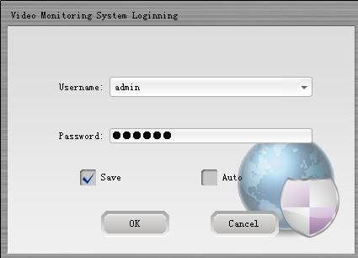
Step 2: Click "OK", then can login to the main program show as below.
Click "Cancel", then cancel to login.
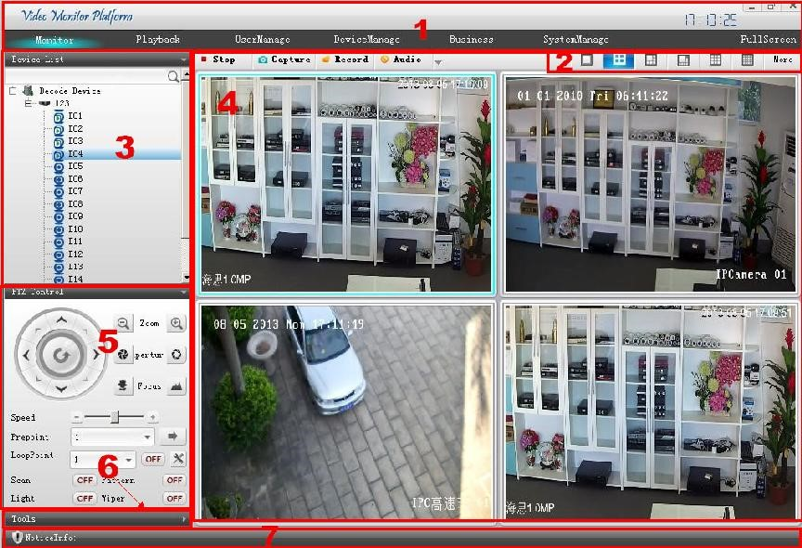

【The basic features of the CMS】
1 | Monitor | Multiple channels realtime surveillance, shortcuts, PTZ Control, etc.
 | Playback | Playback and download
 | User manage | Add, delete, and modify
 | Device manage | Add/delete device, and support auto search.
 | Business | Storage manage, Tour plan, E-map, Alarm-link
 | System manage | Language setting, Start with the OS, Auto login, Start the time record, Restore the preview.  Alarm setting, Time checking, Record store.  Logs configuration, system maintenance etc.
2 | Split Screen | The screen can be divided into one, four, six, eight, nine, sixteen, Twenty five, Thirty six, Forty nine, and Sixty four.
3 | Device list | Display the device as "Directory tree", all the information can be seen on the tree.
4 | Monitoring windows | Multiple channel real time viewing. Have Stop, Capture, Record, and Audio function.
5 | PTZ control | Control the PTZ direction, zoom, focus, and aperture.  PTZ setting, such as Speed, Preset point, Loop point, Scan, Pattern etc..
6 | Tools | Shortcuts.
7 | Notice Info. | Display alarm, log message,etc.
2.2 Log Out
Click the “×”, then log out the CMS.

3 The Features of CMS

3.1 Real time Monitoring
Real time monitoring mainly for monitoring equipment, and can scan the video surveillance equipment directly, also can set tour and PTZ monitoring.

3.1.1 Split Screen
Choose the split screen
The screen can be setted as one, four, six, eight, nine, sixteen, Twenty five, Thirty six, Forty nine, and Sixty four.

3.1.2 Device List
After adding device successfully, it will connect device automatically. If channel name appears, means connected. if the device is not online or the device adds error, then cannot be connected. Double click the channel name, then can see the real time video.
【Other Features】If the device is DVR/NVR/HVR and connected with the CMS. Then click right button of the mouse on the connected device, you can setting Remote setup, Time synchronization, Talkback, Refresh "channel", Open all the main stream, and sub stream,close all channel. If the device is IPC and connected, click right button of mouse, will appear these menu: remote config, sync time, main stream, sub stream.

3.1.3 Video Monitoring
Double click the channel of the device connected in the device list, will appear the operate menu. You can choose the way of opening video, main stream or sub stream.
Right click on the video, it will appear these menu: PTZ simulate, region enlarge, start record, close video, close all video.

3.1.4 PTZ Control
PTZ control interface as below:
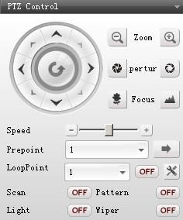
Control the PTZ direction, zoom, focus, and aperture.
PTZ setting, such as Speed, Pre point, Loop point, Scan, Pattern, Light, Wiper.
Opening video interface which you select (Windows have blue frame), so that can control PTZ (the channels’ PTZ setting will not give instruction here).
1)【Direction control】 Control up, down, left, right.
Press the mouse means controlling. Loosen mouse means stop controlling.
2)【Zoom】Adjust and control the zoom of the PTZ camera lens.
Click PTZ zoom lens will reduce. Click PTZ zoom lens will amplify. 3)【Aperture】Adjust and control the aperture distance of the PTZ camera lens.
Click PTZ aperture will reduce. Click PTZ aperture will amplify.
4)【Focus】Adjust and control the focus of the PTZ camera lens.
Click PTZ focus lens will reduce. Click PTZ focus lens will amplify.
5)【Speed】Control the direction of Up,Down, Left, Right, Tour Speed by setting the speed.
- reduce | + amplify
Click or use to set the speed.
6)【Pre Point】Move the PTZ to the Preset Point after input the Preset point.
Choose the preset point or input the number, then click
come to the Pre Point.
7)【Loop Point】Control the tour.
Choose the tour line or input the number, then click to , means the PTZ would move due to the tour. Then click , means stop the tour.
to
8)【Scan】Click and the PTZ would start Scan follow the setting line, click to to stop Scan.
to
9）【Pattern】Click and the PTZ would start Pattern follow the setting line,click
to
to stop Pattern.
to

3.1.5 PTZ Setting
Click enter into the PTZ setting interface as below.
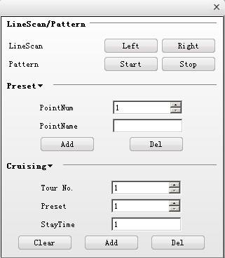

1)【Line Scan】
Via direction button to set the left side of Line Scan, then click to confirm it. The same operation to set the right side, and click to confirm it. Then setting is over.

2)【Pattern】
Clickthen start to record the pattern line. Then back to the PTZ interface to set the
Direction, Zoom, Focus, and Aperture. Next, come back to PTZ setting and click .
The pattern line is setted completely.

3)【Preset】
Input the Preset Point Number, named the Preset Point Name, Stay Time, and set the PTZ Speed. Click and the preset point added. Select the Preset Point Number or input Preset
Point Number, then click and this point deleted.

4)【Cruising】
Setting the Tour Number, Preset and Stay Time. This can Clear, add, and Delete the point.
3.1.6 Tools
【Color Control】
Color Control can adjust the Brightness, Hue, Contrast, and Saturation. Then get the best picture.
Using to adjust the Brightness, Hue, Contrast, and Saturation.
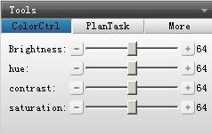

【Plan Task】 (Tour )
Click , then start to tour. Click , then stop tour.
into
into
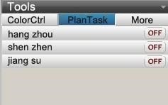

【More】
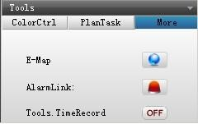

【E-map】
Click , then the E-map will appear on the screen as below.
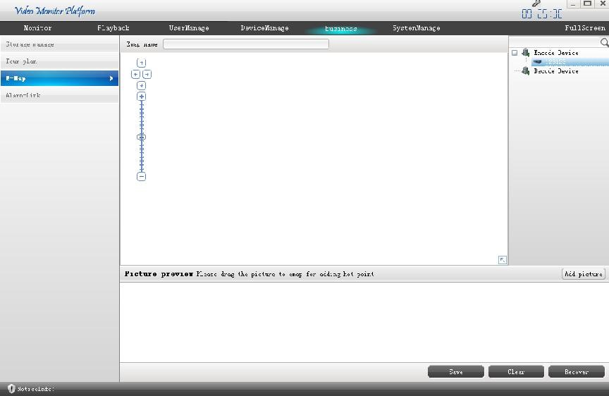

【Alarm Link】
Click
, then the Alarm Link will appear as below.
ON
OFF
【Tools Time Record】 means start the “Video recording plan”. means stop the “Video recording plan”.

3.1.7 Notice Information
Click this area, then will appear info. as below.
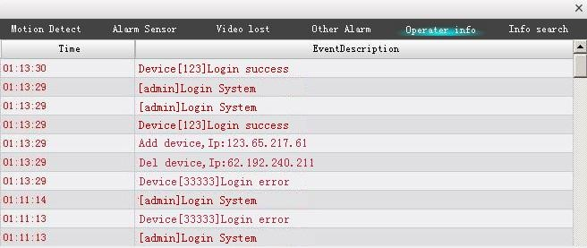

3.2 Device Management
This part include Add, Modify and Delete device, and also can Auto Search device.
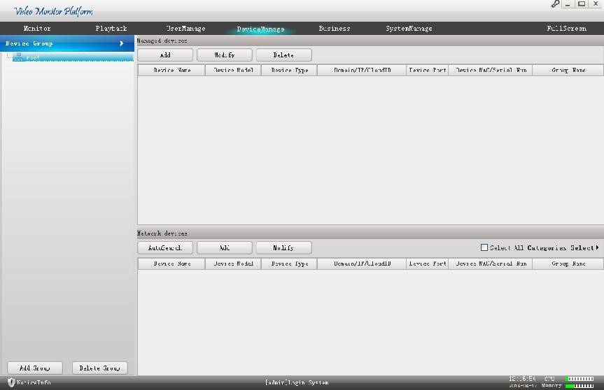

3.2.1 Device Group
【Add Group】: Add device group
【Delete Group】: Delete group and devices in the group.

3.2.2 Network Devices
【Auto Search】：Auto search for LAN devices
【Add 】：Choose the LAN devices and click ,then the devices will be added in the 【Manged devices】box.
【Modify】：choose the LAN devices and click , you can modify the device information, such as device IP or port.
【Select All】：add all LAN devices in “network devices” box.
【Categories Select】: click the triangle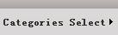, categories select and add.

3.2.3 Manged Devices
【Add Device】Click , then input some correct information of the device. Then click
and the device add into the device list.
【Modify Device】Selected device and then click to modify the information of the device. And then click to save the new information.
【Delete Device】Select device and then click to delete device.
Tip1: click , you can choose log in type, such as IP, Domain, Serial, Cloud as below.
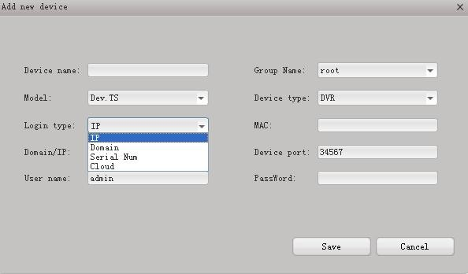

3.2.4 Setting of Auto Search
Click, after fewer minutes, the device will appear. Choose device you need , then click and the device will be added in the managed box, also appear in the device list at Monitor.
Tip 1
The device can not be added repeatedly, and the new device’s name and IP address can not the same with the former added device. If the same, then will notice you as below.
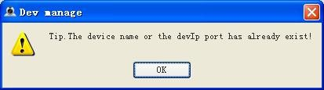
Tip 2
If all device selected, then all device will add into the device list.
Tip 3
If click you can select and add by category.

3.3 Playback
The user can search the video record of the device, also can download the video record, and also can search the local storage of the video record or manual video record.
The interface shown as below.
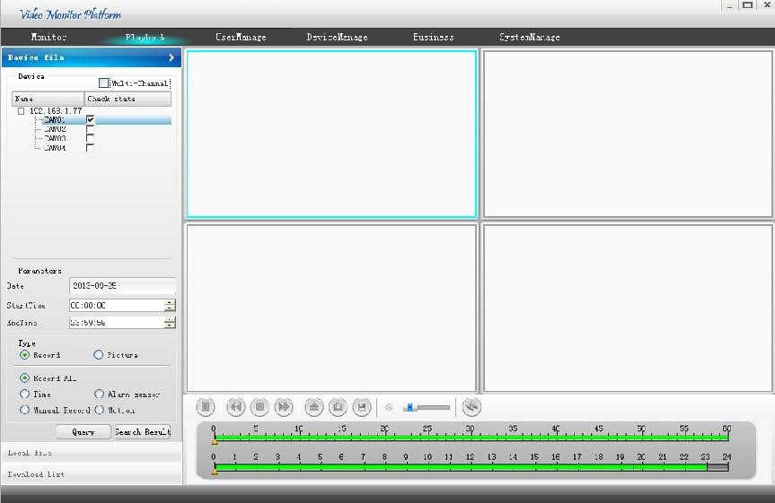

3.3.1 Device file

3.3.1.1 Video Record Retrieval
Video Record Retrieval include many search conditions, they are Channel, Time, Record or Picture , and search type..
Steps shown as below:
First, choose the device and the channel number.
then, choose one channel or multiple channels. Default means single channel, and only playback this channel. If want to multiple playback, please tick the multi-channel box and add the channels (Max four channels) you need. When playback, the added channels will playback synchronously.
next, choose the Date, Start time and End time.
After that, choose record type. It contains Time, Manual Record, Alarm Sensor and Motion type.
finally, click , and the files list in .

3.3.1.2 Video Record Playback
There are two ways to playback
- Playback by record file only one channel
After Choosing search conditions, click “query”, then click”query result”, choose the file you want in the file list, click”play”.
- Playback by time for multiple channels
When choosing channels, tick “muti-channel” box, choose several channel (at most 4 channels), then choose other conditions, click “query”, click the time you want to start playing in the time bar. Then multiple channels will playback synchronously. Open local file
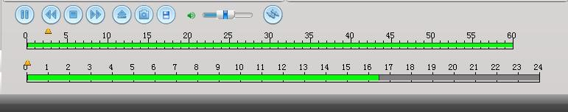
3.3.1.3
Video Record Download
record
slow
Play/pause
stop
quick
snap
audio
Switch bar
The interface shows as below.
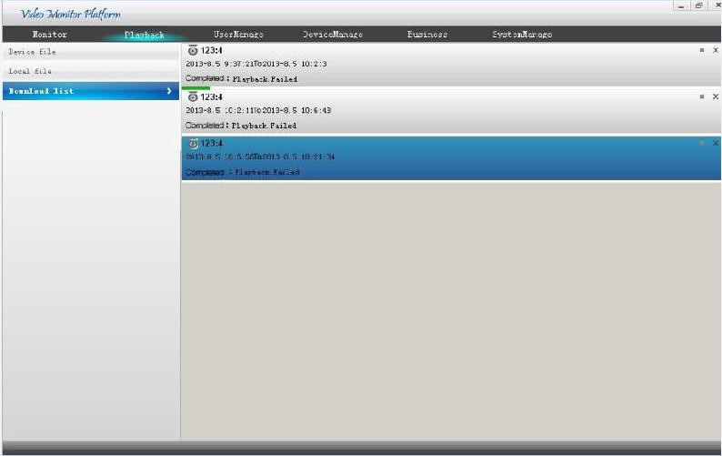
Choose the files you need to download in the query result list. Then click
DOWNLOAD
. support download multiple files.
Download information as below.
【Pause】Click and download pause. Click and download recovery.
【Delete】Click and download delete.
device name and Channel number.
Start and end time of this file.
Show the download speed of this file.

3.3.2 Local File
Local files are stored in the computer’s HDD. Query and playback these files.
The operation is the same as “device file”.
Local file interface shows as below.
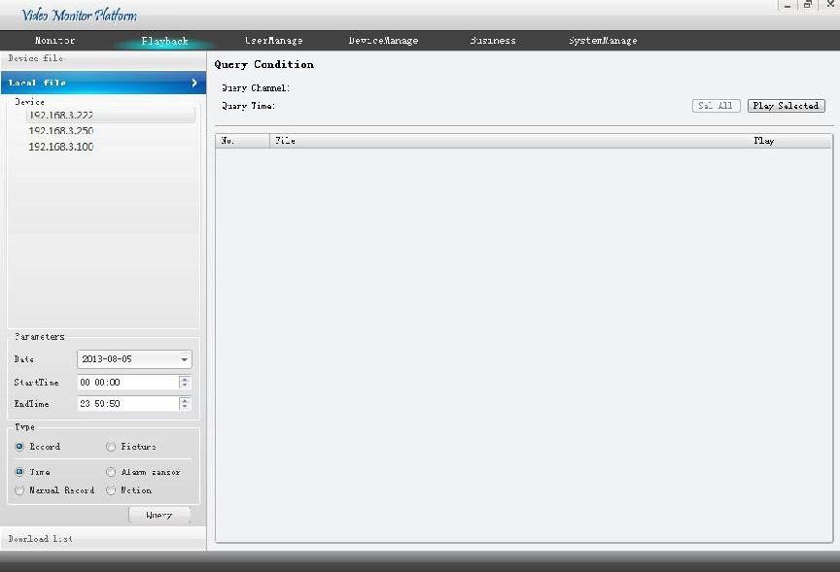

3.4 Business
Business part contains Storage manage, Tour Plan, E-Map, and Alarm-Link. All this can be better management of all device, and have a flexible view of surveillance.

3.4.1 Storage Manage
Memory manage’s interface as below.
Storage manage can real time record and store at local computer. This part can support many types of storage. Such as multiple devices store simultaneously, different period of time storage, normal recording storage and alarm recording storage.
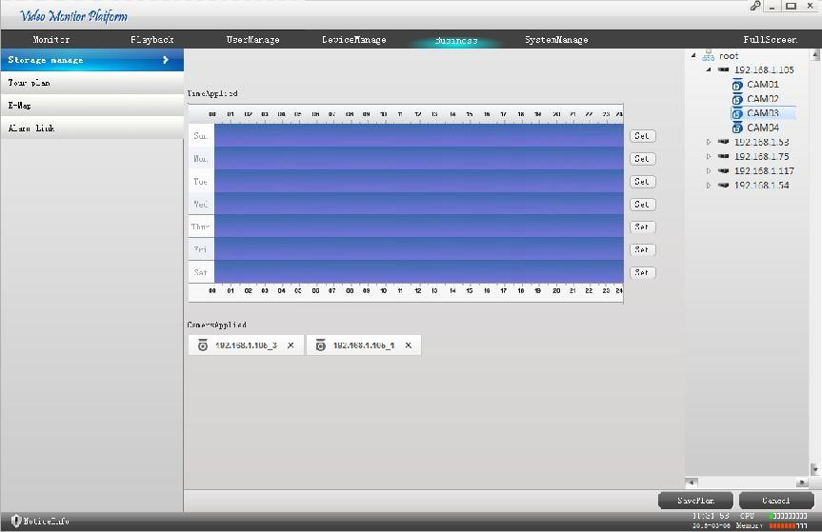
【Operation Steps】
The operation steps of adding storage plan is as following.
Step one, choose the period time need to recording. Multiple time period to choose is able.
Step two, add the camera that need to backup. Choose the channel of device camera, then double click . All the added camera will appear in the "Camera applied".
Step three, click and save all settings.
Step four, click and delete this camera.
in the
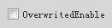: when the capacity left of the disk equal to the minimum value, tick this
box it will overwrite record existed.

3.4.2 Tour Plan
Tour plan can be set many plans for more convenient surveillance.
Tour Plan interface shows as below.
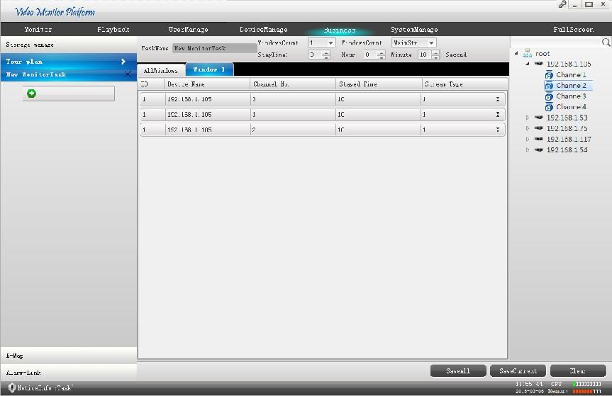

【Operation】
Step One, click to add new item like this .
Step Two, confirm a Task Name, choose the Windows Count and the Stream type, and set the Stay Time. Shown as below.
Step Three, add the camera of the tour plan, choose the window 1 and then drag the camera in the list at the right side.
Step Four, click and save the current tour plan. Clickand save all tour plans.
Step Five, in the Tools’ Plan Task, Click , then start to tour. Click into
into
, then stop tour.
Step Six, click to delete the tour plan.

3.4.3 Electronic Map
E-map can know the location of every device managed.
The E-map interface shows as below.
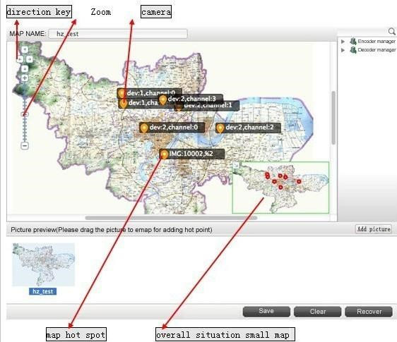

3.4.3.1 The operation of E-map

【Adding Picture】
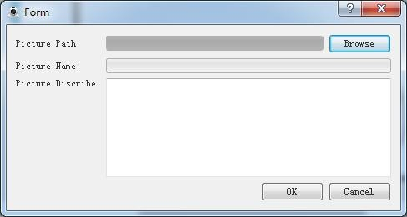
Click
, then this dialog will appear.
OK
The you can choose the Picture path, picture name and picture describe. Then clickand the picture added.
Note: the picture type is BMP or PNG .

3.4.3.2 Arranging the Device on the Map
After adding the picture, double-click the picture, then the pictures will come to the preview window. Then drag the device at the device list at right side into the picture, click to save all configuration..

3.4.3.3 Delete the E-map
REMOVE
Choose the map that you want to delete, and then click right button to. Click then the device on the map cleared. Click , the device
cleared will recover.

3.4.3.4 Setting Hot Spot on E-Map
For example, add “Map of Binjiang” into “Map of Hanzhou”. And consider as a hot spot.
Operation way, drag the “Map of Binjiang” into “Map of Hanzhou” and make the “Map of Binjiang” located at Binjiang. Setting over.

3.4.4 Alarm Link
Alarm-link can feedback the video information in time. The feedback way as following. Such as pop up video, confirmed the location of the device, and snap picture.
Alarm-link interface shows as below.
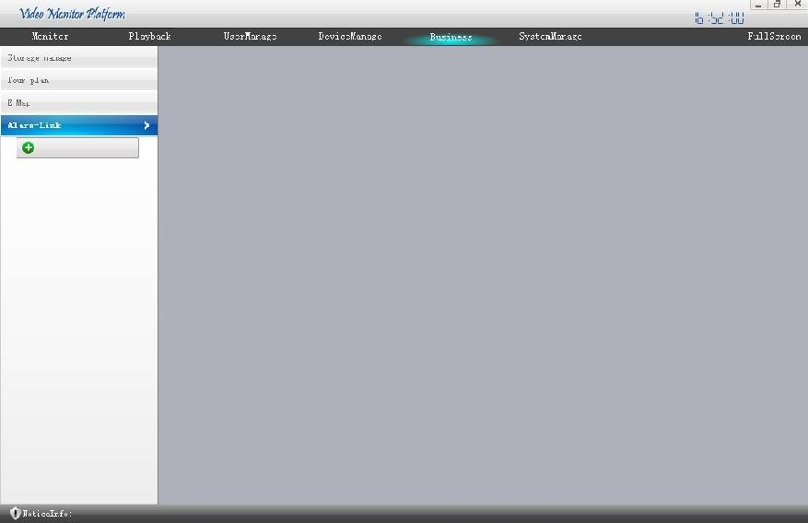
Built alarm link as below.
Step One, click, add new alarm link.
Step Two, choose the alarm type and Then double click the camera into the alarm link list.choose the camera added , modify the showing window, stay time, preset point.
Step Three, decide alarm link record or not (this need to enable storage plan). Set the record time.
Step Four, Set the alarm notice. This can confirm the location of the device, snap picture and play video automatically.
Step Five, click to save the alarm link.
Step six, click to cancel the alarm task in the list.

3.5 User Manage
User manage default the admin as the highest authority user, using admin login can add, delete, modify other user's operation.
The user manage interface as below. Here can scan user and view the user’ permissions to manage the device.
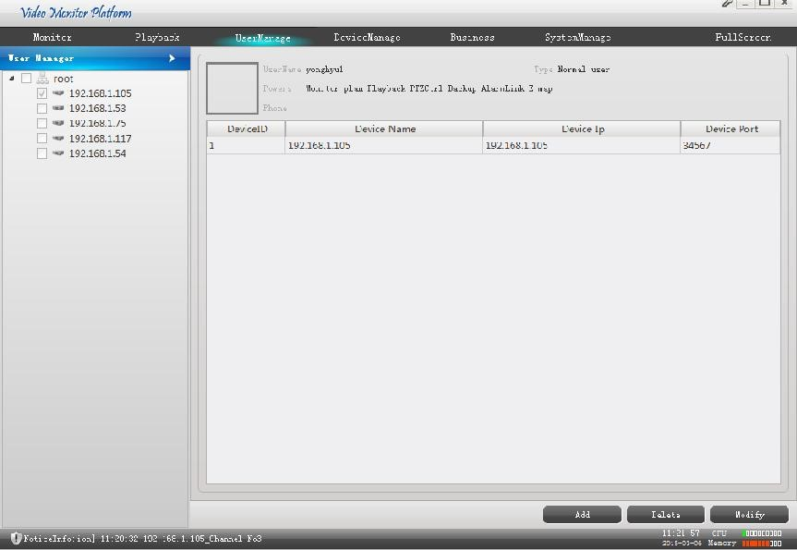

3.6 System Manage
System manage includes Basic Setting, Alarm Setting, Time Checking, Record Store, other Options and system maintenance And each part has many settings as following.
System Manage interface shows as below.
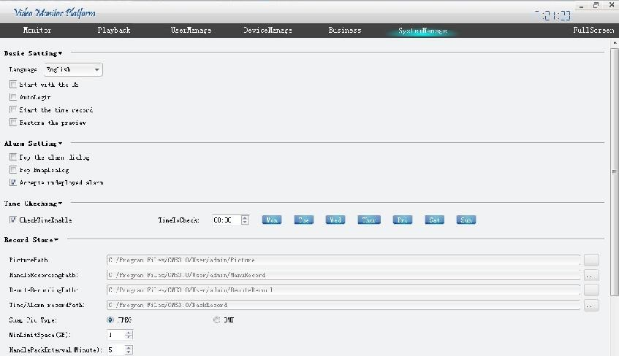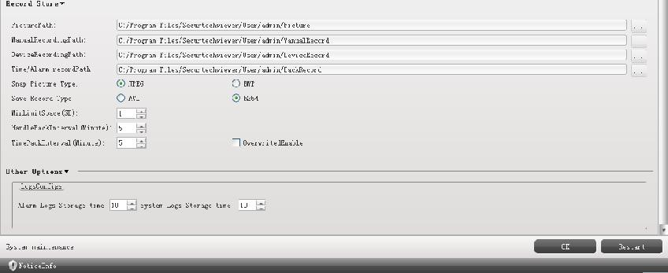

3.6.1 Basic Setting
【Language】 Support eight kinds of languages, they are simple Chinese, traditional Chinese, English, French, Russian, Poland, Spanish, Portuguese.
【start with the OS】CMS start when computer boots up.
【Auto Login】Auto login CMS
【Start the Time Record】start the timing record automatically.
【Restore the Preview】when you restart the CMS, the CMS will run in the same condition after you log out last time. such as monitoring, tour.
【ARSP Server address】input ARSP Server address, use ARSP to visit device.

3.6.2 Alarm setting
【Pop the Alarm Dialog】when alarm , pop up alarm video.
【Pop E-map Dialog】when alarm ,pop up map from which you can find which device alarm.
【Accept Un-deployed Alarm】accept alarm information of device, and prompt.
3.6.3 Time Revision Setting
【Check Time Enable】choose time and weekday for checking time automatically,

3.6.4 Record Store
【Picture Path】Choose as the user will.
【Manual Recording Path】Choose as the user will.
【Device Recording Path】Choose as the user will.
【Time/Alarm Recording Path】Choose as the user will.
The Snap picture type can be JPEG or BMP.
The Save Record type can be AVI or H264.
【MinLimitSpace】，【OverwriteEnable】set the minimum capacity left of disk, when equal to the minimum, enable overwrite, it will overwrite disk and keep recording. Or it will end recording.
【HandlePackInterval】set the time of each manual record.
【TimePackInterval】set the time of each timing record.
3.6.5 Others Options
【Logs Configure】 set the Alarm Logs Storage time and the System Logs Storage Time.

3.6.6 System Maintain
After the software working for long time and need to maintain, the user could click to confirm the software can regular work go on.

