BS-1000 Wireless Communication Station
User’s Manual

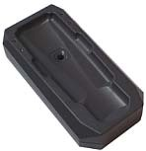

The BS-1000 Communication Station (Comm Station) serves as a direct connection between the PC and the guard tour reader, to allow for immediate uploading of reader data as well as initialization of the readers.

Description of the BS-1000 hardware:

 Power Source
 USB Connection (5v)

 Data transfer speed
 Approximately 30 records per second

 Compatible Guard Tour Reader and Signal Card Format
 EMID (125Khz)

 Status LED Lights
(in the descriptions below, “up” indicates the direction on the BS-1000 where the status LED lights are located):

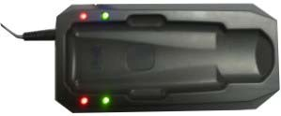

 Red LED – Upper-Left
 Flashing: connected to a guard tour reader.  Green LED – Lower-Left
 Flashing: the BS-1000 is operating normally.
 Red LED – Upper-Right  The BS-1000 is turned on.  Green LED – Lower-Right
 Flashing: the BS-1000 is operating normally.

 Audio Signals
 Long Beep (once)
 The BS-1000 has been turned on and is operating normally.

Operating Instructions

1. Uploading guard tour data from the guard tour reader to the PC
 BS-1000 is able to upload data from guard tour readers wirelessly. Compatible readers include models BP-2002S, BP-2002-W, and BP-2002B-W.
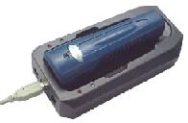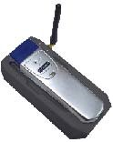

 Attach the BS-1000 to the PC using the provided USB cable.
 Start the patrol management software, and go into the Connect screen.

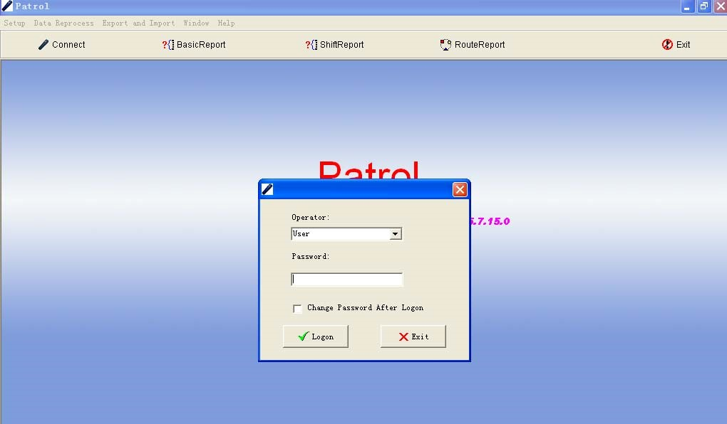
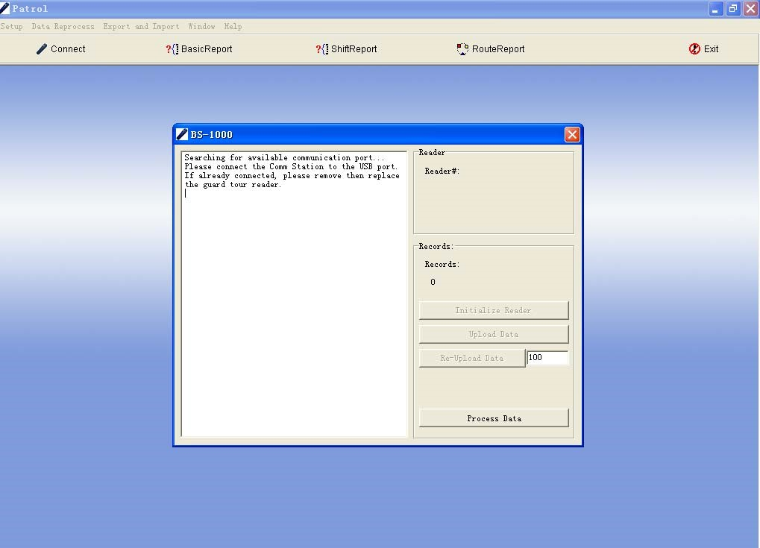

 Set the reader into the indentation on the BS-1000. For reader model BP2002S, please place its reading head between the status lights, and set its top flush against the inside edge of the BS-1000.
 The software will automatically complete the upload and time clock calibration tasks.

2. Reading Signal Cards Using the BS-1000
 The BS-1000 can be used as a signal card reader by the patrol management software, which is convenient when adding signal cards to the system.
 Attach the BS-1000 to the PC using the provided USB cable.
 Place the signal card in the region between its LED status lights. The card number will be displayed on-screen and be recorded by the software.

Troubleshooting

 Not able to upload data from the guard tour readers.
 Check to see if the reader is placed properly on the unit. The reading head of the reader should be between the status lights of the unit, and its top should be flush against the inside edge of the unit.

 The patrol management software is not able to find the BS-1000 unit.
 Please check the condition of the hardware installation by going into the Windows Device Manager.

