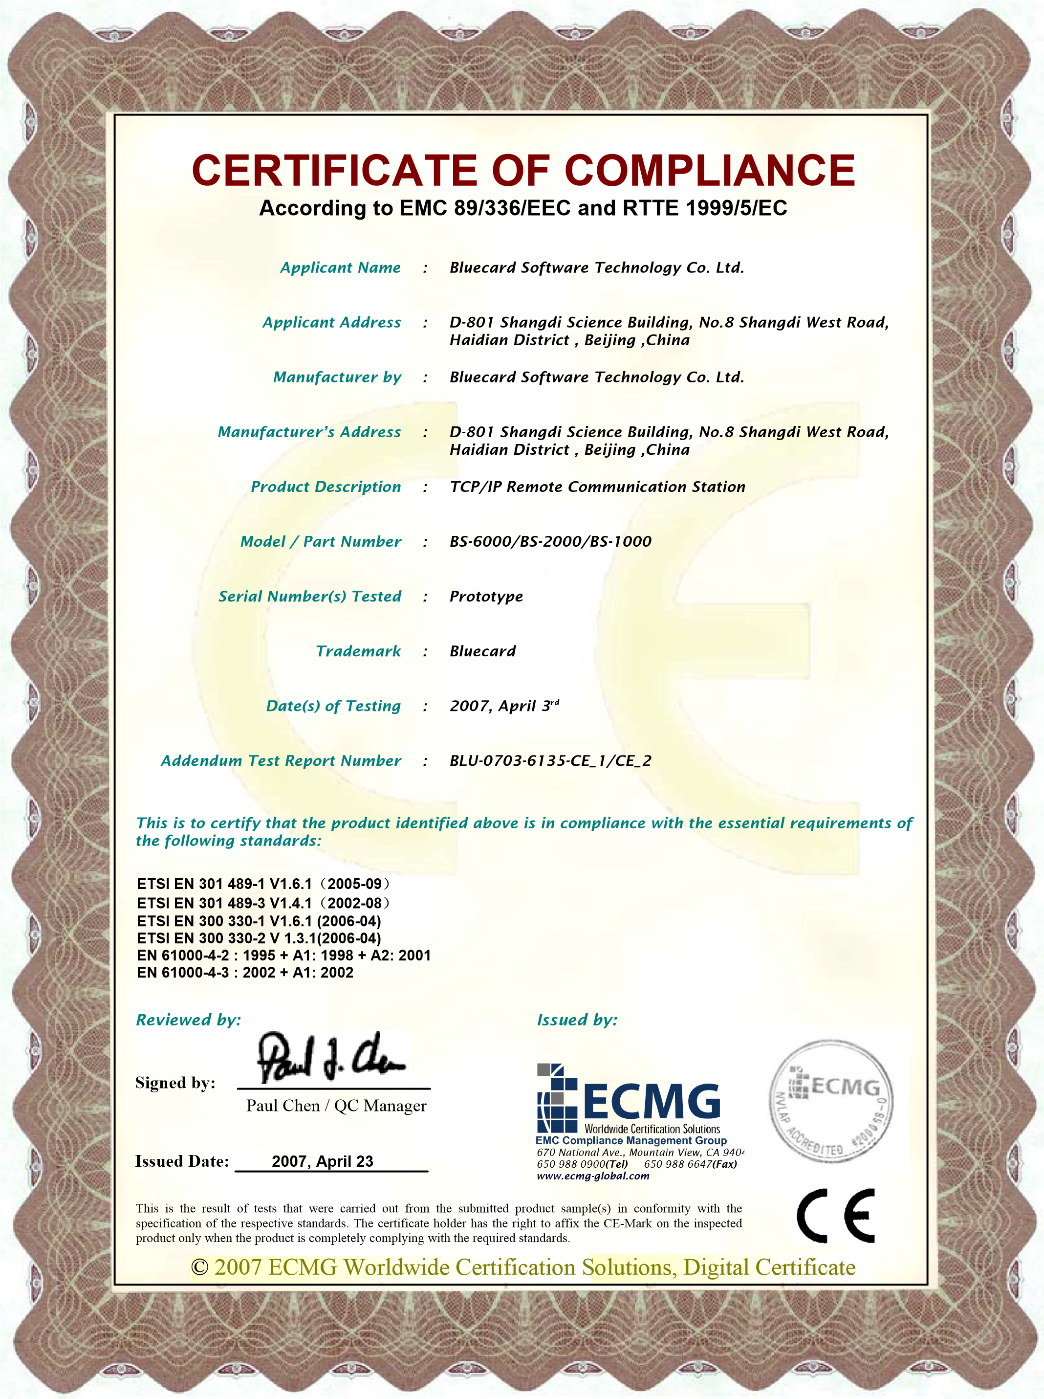
The original document contains watermark. ©2007 Not to be reproduced without the permission of EMC Compliance Management Group.
Certificate No. CE10315

